Leading solution provider of IP-Based video transmission

KIS Pro User Manual(v1.1)

**KIS Multi-party Intercom System**

（kiloview Intercom Server Pro）

Kiloview Intercom Server (KIS) is a multi-party intercom system that supports multiple terminals (32

users/devices in the trial version, unlimited number of terminals in the authorized version), follows the video transmission system and can be used over the Internet. As long as you are a KIS user, you can easily make voice calls at the production site through this intercom system.

**Catalog**

1.KIS Pro Multi-party Intercom System Login 5

2.KIS System Authorization 6

3.Call Management 8

4. Label management 12

4.1.Add label 12

4.2.Member management within the label 12

4.3 Delete and modify labels 13

5.User management 15

5.1. Account user management 15

5.2. Device management 16

5.3. Handheld Terminal Management 18

6.User Center 20

6.1. Authorization Service 20

6.2. Personal Center 20

7.Join the Intercom 21

7.1.Device join the Intercom 21

7.2 Account user Join the Intercom 23

8.Operation logs 24

8.1 Check the Log 24

8.2 Download the Log 26

9 About Version 27



**1.KIS Pro Multi-party Intercom System Login**

Open https://SERVER_IP:8443 in the browser and login to the KIS voice call system. The

default username for logging in to the device is: admin, the password is: admin.

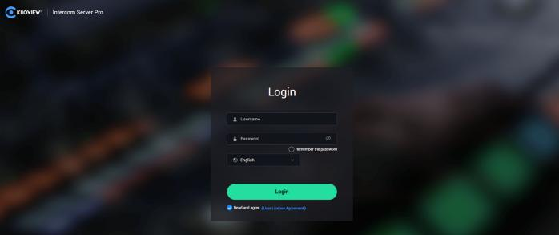

|  |  |
| --- | --- |
|  | **Cautions**  In order to ensure information security, it is recommended that you change your password immediately after logging in for the first time!  The login port of the KIS voice call system is 8443 by default. |



**2.KIS System Authorization**

After log in, you will be prompted for authorization and the remaining service life will be

displayed.

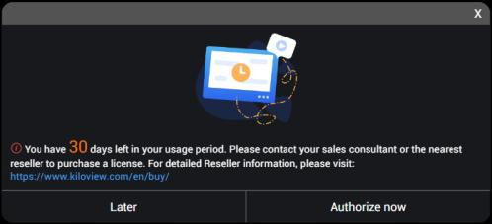

After clicking Authorize Now, you will enter the authorization page, send the machine code of the server to the Kiloview staff to obtain the authorization code, fill in the authorization code, and then click OK to complete the authorization. Click the return arrow in the upper left corner to return to the lobby interface.

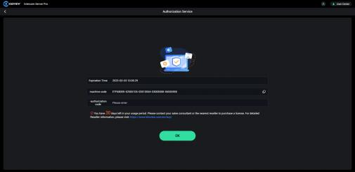

**Instruction:**

l **The Machine code：**The machine code is an identification code generated by the program based on the hardware information of the server, which is unique

l **The authorization code：**The authorization code is generated one-to-one according to the machine

code, so it is exclusive.

**3.Call Management**

（1）Adding New call: click "Call Management", click the icon  to enter the call management page, and then click the icon  to fill in the call name in the pop-up dialog box, and then click "confirm" to add a new call.

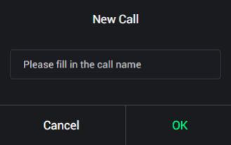

（2） Call management: After the call is added, the call search, edit and add functions

can be realized in the call management page. Click  to view items, rename, stop/start items, delete items, etc(Items can only be deleted when they are not started). The implementation of multi-party voice intercom function must first establish and start the call, and all members must join the corresponding call before they can manage and realize the call function in the call.

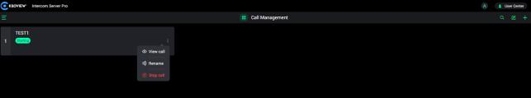



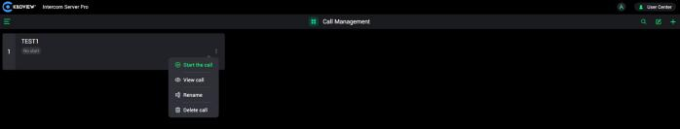

（3）Click "View Call" icon to enter the call details management page. Manage all devices and users in the call, allow or prohibit devices and users to talk, and manage them in channels. You need to add devices and users in member management before you can manage corresponding members in the call.

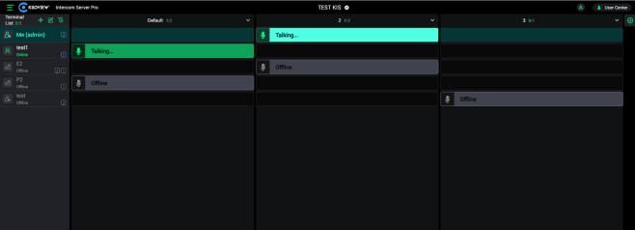

（4）Add device or user to the call: click the icon  to select the user or device to add to the call in the list, and click "confirm" to add to the call.

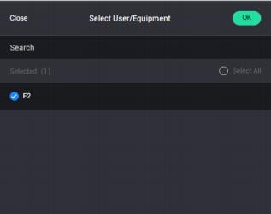



（ 5 ） Management of call members: Click the icon  to select the user or device in the list, click "Delete" and then click "confirm" to delete the added member in the call.

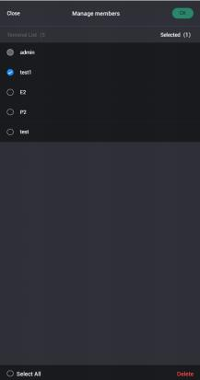

（6）Call members filter: Click the icon  and then select the label, channeling and status information, and click "confirm" to filter the call members that meet these conditions.

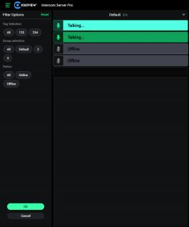



（7）Add channel ： Click  then fill in the name of the channel that you want to add in the pop-up window, then click “sure”.

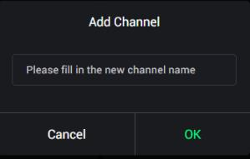

（8）Channel management ：You can rename, enter into and disable the channels by the drop-down box. Voice intercom between channel members cannot be implemented, click the channel blank field with left mouse button realizes the member moves between different channels. You also can mute single user/device in current page.

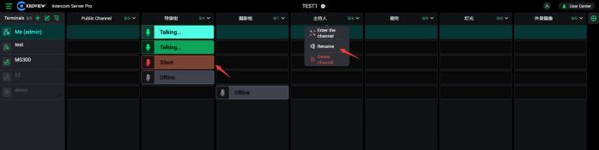

After entering a channel, you can mute devices and users within the channel and adjust the call volume.。 It also support mute all members within the channel.

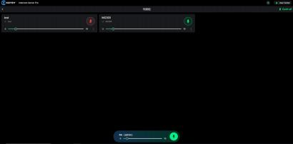



1. **Label management**

**4.1.Add label**

Click “Add label” icon, fill in the label name in the pop-up window and click "OK" to add a new label.

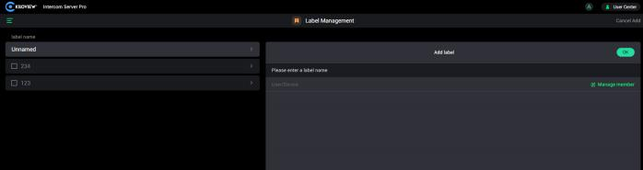

**4.2.Member management within the label**

Select a label and click the member icon. Select the member to be added to the label and click OK.

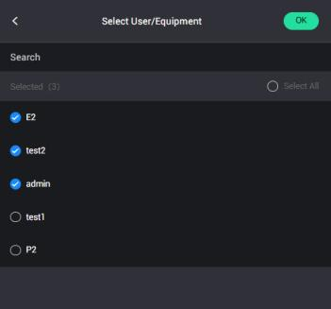

**4.3 Delete and modify labels**

Click the label to be deleted, check the check box on the left, and click the delete button at the bottom to complete the deletion of the label；fill in the new name of the label in the right "label Details" column,



and click "Save" to complete the modification of the label.

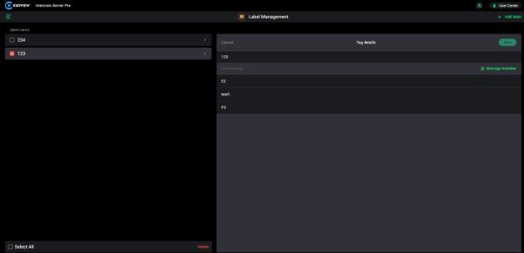



**5.User management**

User management supports the distinction between ordinary users and administrative users, and is divided into account user management, device user management and handheld terminal management.

**5.1. Account user management**

On the account user list page, you can view all existing account users, as well as all account user information, and can also enable / disable account users. See following figure for reference:

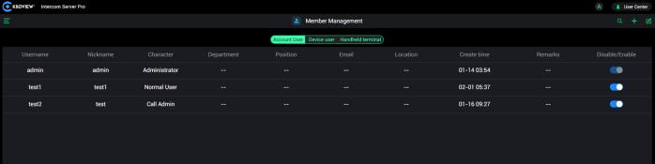

After clicking to add users, there will be a list of information to fill in, “*”means required, the rest is optional, and the information will be displayed in the lobby at the same time. Complete the information and click Save to complete the creation.



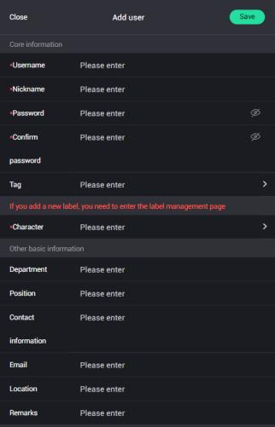

User Name：The username is the account number.

Role ： You can choose the account permission, which is divided into two types: administrators and users.

**5.2. Device management**

In the user list, you can view all existing users, user information, and the enabled/disabled devices



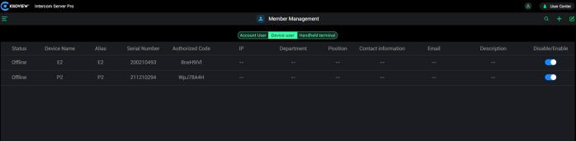



After clicking Add Device, there will be a list of information to be filled in, * means required to fill, the rest are optional and the information will be displayed in the management web UI at the same time. Click OK to complete the creation.

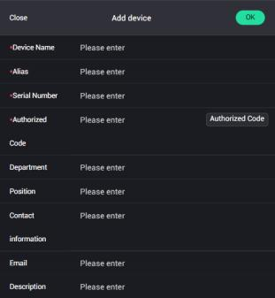

**Introduction**

l **Serial Number：The serial number should match authorization code, otherwise the connection will be failed.**

l **Enable/Disable：Enable/disable the user or device. It cannot login after disabled, unless enabled.**

**5.3. Handheld Terminal Management**

Handheld terminal management is a new feature of the new version of the system. Common handheld terminal devices such as walkie-talkies can be added to the voice intercom system. On the handheld terminal management page, you can view all the added handheld terminals and related terminal information, and enable / disable the terminals.

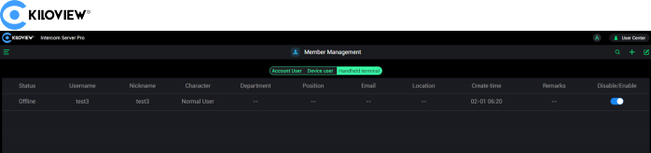

After clicking to add a handheld terminal, there will be a list of information to be filled in *

means required, the rest is optional, and the information will be displayed in the lobby at

the same time. Complete the information and click Save to complete the creation.

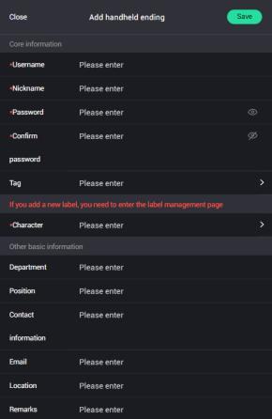



**6.User Center**

The user center supports authorization services, personal information changes, user password changes, and logout.

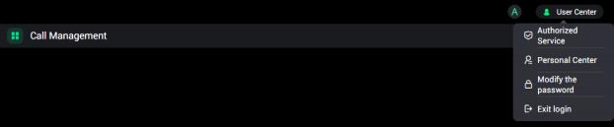

**6.1. Authorization Service**

Click Authorization Service to view the machine code of the server and perform authorization;

**6.2. Personal Center**

Click to enter the Personal Center, click Edit to modify the user's basic information;

3.Change password: Click Change Password, enter the new password twice as prompted, and click OK to complete the password change;

4.Logout: Click Logout to return to the login interface.



**7.Join the Intercom**

**7.1.Device join the Intercom**

To join the voice intercom on the device, you need to update the firmware to the latest version and com plete the authorization at the same time.

1. Add a device on the servers and get the authorization code of the device.

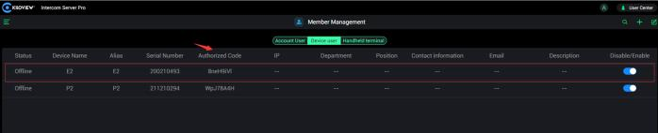

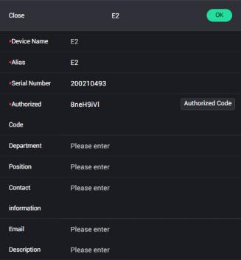



2. Login to devices and turn on the voice intercom function.

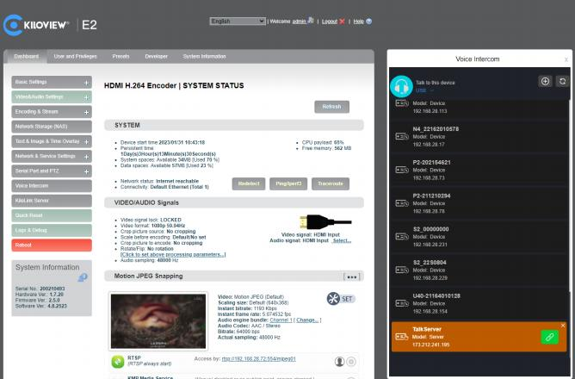



3. Click + at the right side and select the call server in the drop-

down box and fill in the IP address as well as authorization code. Then find the voice interc om server to connect, click, the device and KIS server are connected successfully.

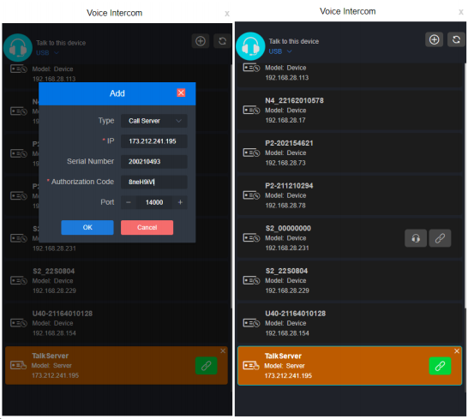

**7.2 Account user Join the Intercom**

After creating a new user, use the account to login to the KIS server (http://server IP:443) in a web browser (chrome, edge, safari) to join the voice intercom.



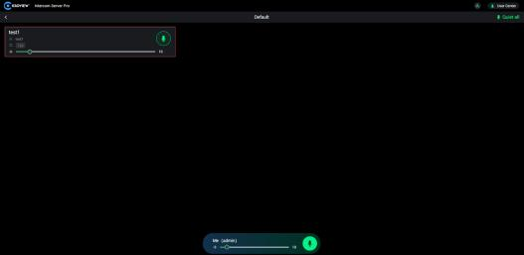

**8.Operation logs**

User can analyze the cause of the problem by viewing the log file to find a solution and ensure the normal operation of the product when there is a problem in the operation of the product.

**8.1 Check the Log**

Click "Operate Log" to open the log page, and user can see information such as login, startup, and upgrade. There will be a error message displayed when a problem occurs.

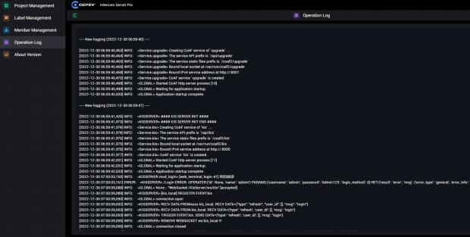



**8.2 Download the Log**

Click "Download Log" to download the log file to the local analysis

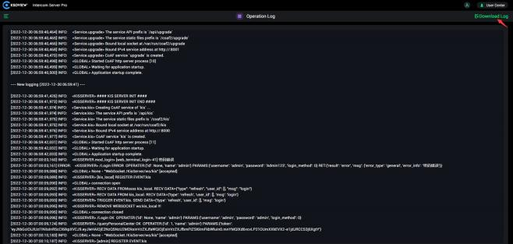



**Cautions**

Only administrators have permission to operate log management, view logs and download logs.



**9 About Version**

Users can upload the firmware to the system and upgrade the product in the system. Each product is continuously improved, so we will continue to upgrade the functions and fix bugs of the products. If the product supports new functions or bug fixes, the product will be upgraded in the form of an upgrade package. If necessary, please contact technical support to obtain the upgrade package.

Click "About Version" and select "Firmware Upgrade" to enter the firmware upgrade interface. After uploading the firmware upgrade package to the system, click the "Upgrade" button to start the upgrade. The entire upgrade process will last about 2-3 minutes (depending on the firmware size and network conditions), and the device will automatically restart. Remember not to cut off the power during the upgrade process, otherwise the upgrade will fail and the device will be abnormal. If you need help, please contact technical support to assist in completing the upgrade operation.

