**Kiloview Intercom Server Pro**

**Voice Intercom Server Professional Edition**

**Deployment Manual V1. 3**

Changsha KILOVIEW Electronics Technology Co., Ltd.

**Legal Notice**

If you accept this document from Changsha kiloview Electronic Technology Co., Ltd. (hereinafter referred to as "kiloview Electronic"), it means that you have agreed to the following terms. If you do not agree to the following terms, please stop using this document.

The copyright of this document belongs to Changsha kiloview Electronic Technology Co., Ltd. Any rights not expressly granted in this document are reserved. The document contains proprietary information of kiloview Electronic. No unit or individual may copy, transmit, distribute, use or disclose this document and any pictures, tables, data and other information contained in this document without the prior written permission of kiloview Electronic.

is a registered trademark of Kiloview Electronics. The names and logos of Kiloview Electronics products are trademarks or registered trademarks of Kiloview Electronics. Other product or company names mentioned in this document may be trademarks or registered trademarks of their respective owners. Without the prior written consent of Kiloview Electronics or the third-party right holder, reading this document does not grant the reader any right to use any mark appearing in this document by implication, estoppel or otherwise.

This product complies with the design requirements for environmental protection and personal safety. The storage, use and disposal of the product should comply with the product manual, relevant contracts or the laws and regulations of relevant countries.

This document is provided on an "as is" and "as is only" basis. The information in this document will be continuously updated as Kiloview Electronics' products and technologies advance, and Kiloview Electronics will no longer notify you of updates to such information.

For matters not covered in this document, please visit the Kiloview Electronics website www.kiloview.com for relevant information and technical support.

**Table of contents**

[Chapter 1 System Introduction 1](#_Toc15506)

[1.1. System Introduction 1](#_Toc9807)

[1.2. System Features 2](#_Toc15504)

[Chapter 2 Product Parameters 3](#_Toc22419)

[2.1. Authorization Matrix 3](#_Toc9379)

[2.2. Hardware Configuration 4](#_Toc31955)

[2.3. System parameters 4](#_Toc10516)

[2.4. Software Environment 5](#_Toc27923)

[2.5. Port Description 6](#_Toc20805)

[2.6. Network Description 7](#_Toc13519)

[Chapter 3 Installation and Deployment 8](#_Toc14277)

# Chapter 1 System Introduction

## 1.1. System Introduction

Kiloview Intercom Server Pro (KIS Pro for short) is a multi-party voice call system that was developed to make large-scale multi-person collaboration scenarios more efficient. It is a simple and practical multi-party voice call platform that can be logged in through a variety of methods (Kiloview codec, Kiloview voice panel, mobile phone/Pad, web page, handheld terminal).

When users need to participate in work, they can use KIS Pro to achieve a more efficient and convenient call experience. It can conduct multi-party voice calls across the Internet, and users can participate in it from any location and multiple devices.

Compared with the previous generation of products, KIS Pro has a clearer operating interface, more flexible multi-party call quantity, more efficient channel management, and more accurate member search function. It is an excellent software that can truly help you solve all multi-party voice call problems.

## 1.2. System Features

KIS Pro is a multi-party voice call system with the characteristics of low cost, multi-terminal, cross-Internet, and IP voice calls.

# Chapter 2 Product Parameters

**2.1. Authorization Matrix**

|  |  |  |
| --- | --- | --- |
| **Product Parameters** | **Before authorization** | **After authorization** |
| Number of calls | No restrictions | No restrictions |
| Multi-party call | support | support |
| Call Management | support | support |
| Channel Management | support | support |
| One-touch mute  Unmute | support | support |
| Disable Members | support | support |
| Membership Management | support | support |
| Operation log | support | support |
| Tag Management | support | support |
| Version Upgrade | Support any version upgrade | Support any version upgrade |
| Call Terminal | LinkDeck/Encoder/  Decoder/NDI Encoder/Decoder/PC/Pad | LinkDeck/Encoder/  Decoder/NDI Encoder/Decoder/PC/Pad |
| Language Switching | Simplified Chinese/English | Simplified Chinese/English |
| Trial duration | 30-day trial | Authorization payment [controlled by authorization] |

## 2.2. Hardware Configuration

Minimum system requirements:

|  |  |
| --- | --- |
| CPU | Intel Core i5+ |
| harddisk | 40G SSD + |
| Memory | 4GB+ |

## 2.3. System parameters

|  |  |
| --- | --- |
| System version | Ubuntu 20.04.6 LTS (recommended) |
| Kernel version | Linux ubuntu 5.15.0-107-generic (recommended) |
| Codename | focal |

## 2.4. Software Environment

|  |  |
| --- | --- |
| Docker | **Docker version:**  **Client:**  Version: 24.0.5  API version: 1.43  Go version: go1.20.3  **Server:**  Engine:  Version: 24.0.5  API version: 1.43 (minimum version 1.12)  Go version: go1.20.3  Container:  Version: 1.7.2  **Run:**  Version: 1.1.7-0ubuntu1~20.04.2  Docker init:  Version: 0.19.0 |
| ufw | **sudo ufw enable**  **#TCP**  sudo ufw allow 8443:8443/tcp  sudo ufw allow 81:81/tcp  #sudo ufw allow Customized Port **:** Customized Port /tcp  **#UDP**  sudo ufw allow 2000:40000/udp  sudo ufw allow 16000:17000/udp  #sudo ufw allow Customized Port **:** Customized Port /udp  **sudo ufw commit**  **Tip：** you need enable ufw and commit the rule ,otherwise no effection |

**2.5. Port Description**

TIP1: In the network of the cloud service provider, the corresponding service ports need to be opened in the security group (firewall).

TIP2: The following service ports need to be opened on the ECS server.

**Static port range**

|  |  |  |
| --- | --- | --- |
| **Port range [static]** | **protocol** | **effect** |
| 8443:8443 | TCP | KIS Pro Web Access (HTTPS) |
| 81:81 | TCP | KIS Link Device external access |

**Dynamic port range**

|  |  |  |
| --- | --- | --- |
| **Port Range [dynamic]** | **protocol** | **effect** |
| 16000:17000 (default) | UDP | Audio data communication port range |
| 2000:40000 | UDP | Max audio data communication port range |

**2.6. Network Description**

TIP: If all the communication devices are within the same local area network as KIS Pro, then the KIS Pro voice intercom server does not require a public IP address. Otherwise, KIS Pro needs a public IP address.

Taking into account the hardware and maintenance costs of the server, it is recommended to rent an ECS with a public EIP from a cloud service provider. Cloud service providers such as Alibaba Cloud, Tencent Cloud, Huawei Cloud, AWS, etc.

According to the number of simultaneous call users, the bandwidth requirements of several scales are listed below

|  |  |
| --- | --- |
| **Number of simultaneous users** | **Bandwidth requirement (Mbps)** |
| 10 | 8 |
| 20 | 16 |
| 30 | 24 |

# Chapter 3 Installation and Deployment

If you have purchased and configured an ECS cloud server with Ubuntu 20.04 LTS system pre-installed according to the requirements in "Chapter 2 Product Parameters", and correctly installed the Docker runtime environment according to the requirements in "Software Environment Parameters", please refer to the official Docker installation method to install the Docker runtime environment:

[Install Docker Engine on Ubuntu | Docker Docs](https://docs.docker.com/engine/install/ubuntu/" \l "install-from-a-package)

<https://docs.docker.com/engine/install/ubuntu/#install-from-a-package>

After deploying the Docker environment, start deploying KIS Pro

#TIP: Before installing KIS Pro, the following three steps must be checked and executed in the operating system.

1. Log in to the system using XShell first, and grant the ordinary user the sudo permission to execute the installation in the operating system.
2. Use the command "sudo systemctl enable docker.service" to set the docker service to start automatically.

3. Use the command "sudo mkdir -p /usr/local/bin/kis\_db" to create the data storage directory for KIS Pro.

**Get Docker Image Method One**

|  |
| --- |
| **# docker pull kiloview/kis-image**  **Or with version Tag:**  **# docker pull kiloview/kis-image:1.10.0025** |

**Get Docker Image Method Two**

1. Download the image file

|  |
| --- |
| **# wget https://www.kiloview.com/downloads/Firmware/Kiloview-Intercom-Server-Pro/kiloview\_kis\_image\_<kis\_version\_id>.tar​​​​​​​​​​​​**  **#Example:**  wget https://www.kiloview.com/downloads/Firmware/Kiloview-Intercom-Server-Pro/kiloview\_kis\_image\_1.10.0025.tar |

2. Unzip and load the voice intercom image into Docker

|  |
| --- |
| **# docker load -i kiloview\_kis\_image\_<kis\_version\_id>.tar**  **#Example:**  docker load -i kiloview\_kis\_image\_1.10.0025.tar |

**Create and run the KIS Pro container image**

|  |
| --- |
| #Run the container image  docker run --name=KisServer --log-driver=none -idt --network host --privileged=true --restart=always -v /usr/local/bin/kis\_db/:/usr/local/bin/kis/KisServer/db/ -v /etc/localtime:/etc/localtime:ro kiloview/kis-image:1.10.0025 /usr/local/bin/kis/start.sh |

**Log in to KIS Pro server**

|  |
| --- |
| https://SERVER\_IP:8443  Username：admin  Password：admin |

As shown in the following figure:

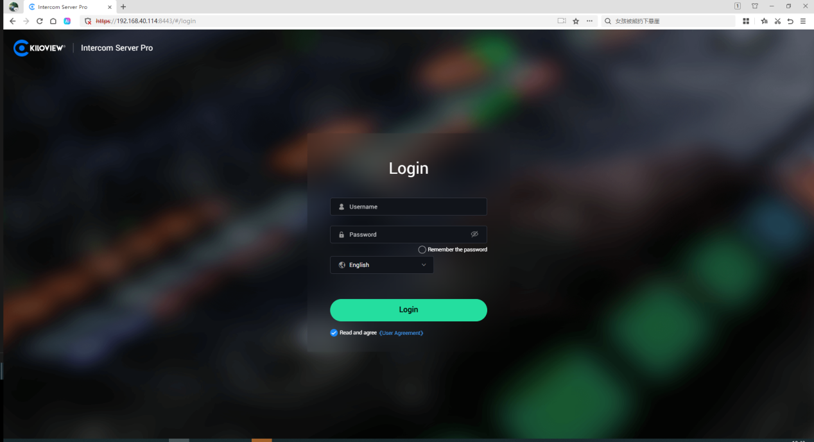

Thanks for reading!

**Changsha Kiloview Electronic Technology Co., Ltd.**   
Contact number: 0731-88315979   
Website: [www.kiloview.com](http://www.kiloview.com" \t "_blank)   
Official Weibo: KILOVIEW Kiloview Technology   
Technical Support Email: support@kiloview.com   
Technical Support Hotline: 18573195156/18573195256   
Address: 106/109, Building B4, Changsha Island, at the intersection of Huijin Road and Huanbao Middle Road, Yuhua District, Changsha